Computer Language Coding Concepts

Return Values in a Diagram
As discussed in the article Return Values, the new computer language does not limit the amount of output objects. Any object readable from the outside, may be an output object.

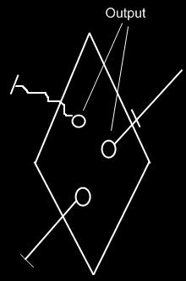

The correct usage of the term output will be discussed only later, in the Advanced Command Topics.

See also: Return Values

Author & Copyright: Jan-Joost van Zon Date: September 30, 2008 – September 30, 2008 Location: Oosterhout, The Netherlands Status: Finished

